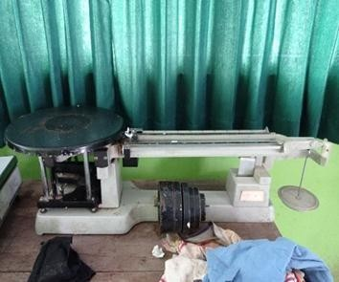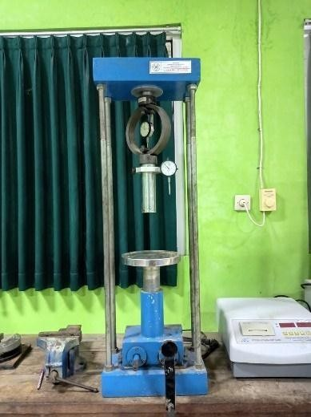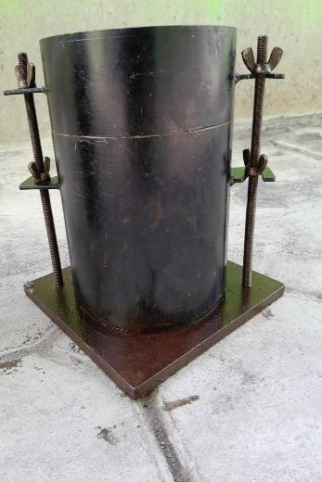

# GAMBAR ALAT DAN BAHAN PENGUJIAN CBR LABORATURIUM

Gambar VII.7 Mesin Uji CBR

Gambar VII.8 Mould atau Cetakan

Gambar VII.9 Timbangan

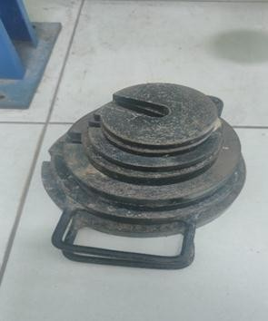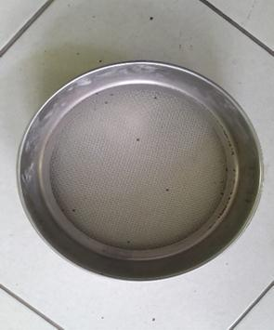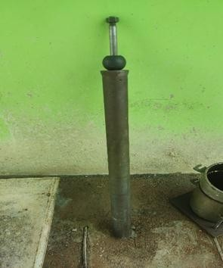

Gambar VII.10 Keping Beban

Gambar VII.11 saringan No.4

Gamabar VII.12 Penumbuk

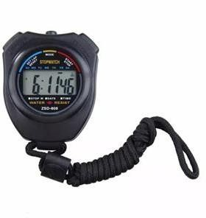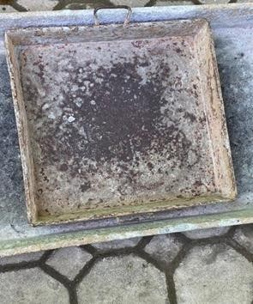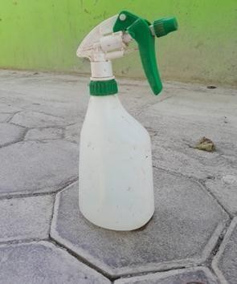

Gambar VII.13 Stopwatch

Gambar VII.14 Loyang

Gambar VII.15 Botol Semprot

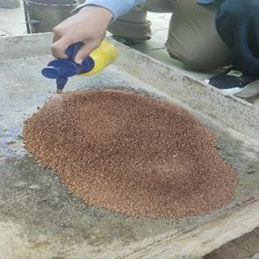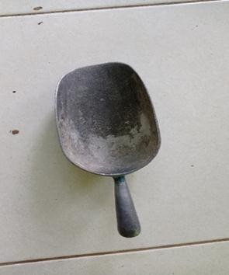

Gambar VII.16 Contoh Tanah Uji

Gambar VII.17 Cetok

**Grafik VII.1 Hubungan Beban dan Penetrasi**

1000

900

800

700

600

500

400

300

200

100

0

**CBR 0.2 INCH = 14,49%**

**CBR 0.1 INCH = 14,66%**

0

0,1

0,2

0,3

0,4

0,5

0,6

**Penetrasi (in)**

Beban Penetrasi CBR (%)

**Beban Penetrasi**

|  |  |  |  |  |  |
| --- | --- | --- | --- | --- | --- |
| Waktu | Penetrasi | | Pembacaan arloji ukur beban | Beban Penetrasi  = Pembacaan Arloji x k | CBR |
| (menit) | mm | In | divisi | Ibs | (%) |
| 0 | 0 | 0 | 0 | 0 |  |
| 0.25 | 0.32 | 0.0125 | 2 | 60.65 |  |
| 0.5 | 0.64 | 0.025 | 3.5 | 106.13 |  |
| 1 | 1.27 | 0.05 | 4.5 | 136.45 |  |
| 1.5 | 1.91 | 0.075 | 5.5 | 166.78 |  |
| 2 | 2.54 | 0.1 | 6.5 | 197.10 | 6.57 |
| 3 | 3.81 | 0.15 | 7 | 212.26 |  |
| 4 | 5.08 | 0.2 | 8 | 242.58 | 5.39 |
| 6 | 7.62 | 0.3 | 9 | 272.91 |  |
| 8 | 10.16 | 0.4 | 12 | 363.88 |  |
| 10 | 12.70 | 0.5 | 13 | 394.20 |  |

Gambar VII.4 Grafik Hubungan Beban dan Penetrasi Percobaan ke-1



**Grafik VII.2 Hubungan Beban dan Penetrasi**

2250

2000

1750

1500

1250

1000

750

500

250

0

**CBR 0.2 INCH = 31,67%**

**CBR 0.1 INCH = 30,32%**

0

0,1

0,2

0,3

0,4

0,5

0,6

**Penetrasi (in)**

Beban Penetrasi CBR (%)

**Beban Penetrasi**

|  |  |  |  |  |  |
| --- | --- | --- | --- | --- | --- |
| Waktu | Penetrasi | | Pembacaan  arloji ukur beban | Beban Penetrasi  = Pembacaan Arloji x k | CBR |
| (menit) | mm | in | divisi | Ibs | (%) |
| 0 | 0 | 0 | 0 | 0 |  |
| 0.25 | 0.32 | 0.0125 | 1 | 30.32 |  |
| 0.5 | 0.64 | 0.025 | 2 | 60.65 |  |
| 1 | 1.27 | 0.05 | 3 | 60.65 |  |
| 1.5 | 1.91 | 0.075 | 4 | 121.29 |  |
| 2 | 2.54 | 0.1 | 5 | 151.62 | 5.05 |
| 3 | 3.81 | 0.15 | 8 | 242.58 |  |
| 4 | 5.08 | 0.2 | 12 | 363.88 | 8.09 |
| 6 | 7.62 | 0.3 | 14 | 424.52 |  |
| 8 | 10.16 | 0.4 | 16 | 485.17 |  |
| 10 | 12.70 | 0.5 | 21 | 636.78 |  |

Gambar VII.5 Grafik Hubungan Beban dan Penetrasi Percobaan ke-2



3. Percobaan ke-3 (65 tumbukan)

Diketahui : kalibrasi proving ring (k) = 30,32300 lbf/devisi Tabel VII.3 Hasil perhitungan percobaan ke-3

|  |  |  |  |  |  |
| --- | --- | --- | --- | --- | --- |
| Waktu | Penetrasi | | Pembacaan  arloji ukur beban | Beban Penetrasi  = Pembacaan Arloji x k | CBR |
| (menit) | mm | in | divisi | Ibs | (%) |
| 0 | 0 | 0 | 0 | 0 |  |
| 0.25 | 0.32 | 0.0125 | 2 | 60.65 |  |
| 0.5 | 0.64 | 0.025 | 3 | 90.97 |  |
| 1 | 1.27 | 0.05 | 7 | 212.26 |  |
| 1.5 | 1.91 | 0.075 | 11 | 333.55 |  |
| 2 | 2.54 | 0.1 | 22 | 667.11 | 22.24 |
| 3 | 3.81 | 0.15 | 41 | 1243.24 |  |
| 4 | 5.08 | 0.2 | 43 | 1303.89 | 28.98 |
| 6 | 7.62 | 0.3 | 47 | 1425.18 |  |
| 8 | 10.16 | 0.4 | 50 | 1516.15 |  |
| 10 | 12.70 | 0.5 | 52 | 1576.80 |  |



**Grafik VII.3 Hubungan Beban dan Penetrasi**

3500

3150

2800

2450

2100

1750

1400

1050

700

350

0

0 0,1 0,2 0,3 0,4 0,5

0,6

**Penetrasi (in)**

Beban Penetrasi CBR (%)

|  |  |  |  |  |  |
| --- | --- | --- | --- | --- | --- |
|  |  |  |  |  |  |
|  |  |  |  |  |  |
| **CBR 0.2 INCH = 53,91%** | | |  |  |  |
|  |  |  |  |  |  |
|  |  |  |  |  |  |
| **CBR 0.1 INCH = 60,65%** | | |  |  |  |
|  |  |  |  |  |  |
|  |  |  |  |  |  |
|  |  |  |  |  |  |
|  |  |  |  |  |  |

Gambar VII.6 Grafik Hubungan Beban dan Penetrasi Percobaan ke-3

**Beban Penetrasi**

|  |  |  |  |  |  |
| --- | --- | --- | --- | --- | --- |
| Waktu (menit) | Penetrasi | | Pembacaan  arloji ukur beban | Beban penetrasi = pembacaan arloji ukur beban x k | |
| mm | in | Divisi | lb | kN |
| 0 | 0 | 0 | 0 | 0 | 0.0000 |
| 1/4 | 0,32 | 0,0125 | 2 | 60,65 | 0,2698 |
| 1/2 | 0,64 | 0,025 | 3 | 90,97 | 0,4047 |
| 1 | 1,27 | 0,050 | 5 | 151,62 | 1,6744 |
| 1 1/2 | 1,91 | 0,075 | 6 | 181,94 | 1,8093 |
| 2 | **2,54** | **0,10** | **7** | **212,26** | **1,9442** |
| 3 | 3,81 | 0,15 | 8,1 | 245,62 | 1,0926 |
| 4 | **5,08** | **0,20** | **9** | **272,91** | **1,2140** |
| 6 | 7,62 | 0,30 | 12 | 363,88 | 1,6186 |
| 8 | 10,16 | 0,40 | 13 | 394,20 | 1,7535 |
| 10 | 12,70 | 0,50 | 13,5 | 409,36 | 1,8209 |

|  |  |  |  |  |  |  |  |
| --- | --- | --- | --- | --- | --- | --- | --- |
| Nilai CBR (%) | | | | | | | |
| 2,54 mm | | | | 0,10 in | | | |
| 14,5 x 30,32300 | x | 100 | = 32,94 | 14,5 x 30,32300 | x | 100 | = 0,15 |
| 13.35 | 3000 |
| 5,08 mm | | | | 0,20 in | | | |
| 21,5 x 30,32300 | x | 100 | = 48,83 | 21,5 x 30,32300 | x | 100 | = 0,14 |
| 13.35 | 4500 |

Hari, tanggal : Rabu,01 November 2023 No. Contoh 2

Tempat : Laboratorium UMPwr Tumbukan/lapis 10

|  |  |  |  |  |  |
| --- | --- | --- | --- | --- | --- |
| Waktu (menit) | Penetrasi | | Pembacaan  arloji ukur beban | Beban penetrasi = pembacaan arloji ukur beban x k | |
| mm | in | Divisi | lb | kN |
| 0 | 0 | 0 | 0 | 0 | 0.0000 |
| 1/4 | 0,32 | 0,0125 | 3,5 | 106,13 | 0,4721 |
| 1/2 | 0,64 | 0,025 | 7 | 212,26 | 0,9442 |
| 1 | 1,27 | 0,050 | 16 | 485,17 | 2,1581 |
| 1 1/2 | 1,91 | 0,075 | 24 | 727,75 | 3,2372 |
| 2 | **2,54** | **0,10** | **30** | **909,69** | **4,0465** |
| 3 | 3,81 | 0,15 | 36 | 1091,63 | 4,8558 |
| 4 | **5,08** | **0,20** | **36,5** | **1106,79** | **4,9232** |
| 6 | 7,62 | 0,30 | 43 | 1303,89 | 5,8000 |
| 8 | 10,16 | 0,40 | 51 | 1546,47 | 6,8791 |
| 10 | 12,70 | 0,50 | 51,5 | 1561,63 | 6,9465 |

|  |  |  |  |  |  |  |  |
| --- | --- | --- | --- | --- | --- | --- | --- |
| Nilai CBR (%) | | | | | | | |
| 2,54 mm | | | | 0,10 in | | | |
| 35 x 30,32300 | x | 100 | = 79,50 | 35 x 30,32300 | x | 100 | = 0,35 |
| 13.35 | 3000 |
| 5,08 mm | | | | 0,20 in | | | |
| 47 x 30,32300 | x | 100 | = 106,76 | 47 x 30,32300 | x | 100 | = 0,32 |
| 13.35 | 4500 |

|  |  |  |
| --- | --- | --- |
| Hari, tanggal : Rabu,01 November 2023 | No. Contoh | 3 |
| Tempat : Laboratorium UMPwr | Tumbukan/lapis | 65 |

|  |  |  |  |  |  |
| --- | --- | --- | --- | --- | --- |
| Waktu (menit) | Penetrasi | | Pembacaan  arloji ukur beban | Beban penetrasi = pembacaan arloji ukur beban x k | |
| mm | in | Divisi | lb | kN |
| 0 | 0 | 0 | 0 | 0 | 0.0000 |
| 1/4 | 0,32 | 0,0125 | 0,1 | 3,03 | 0,0135 |
| 1/2 | 0,64 | 0,025 | 1,5 | 45,48 | 0,02023 |
| 1 | 1,27 | 0,050 | 5 | 151,62 | 0,6744 |
| 1 1/2 | 1,91 | 0,075 | 9 | 272,91 | 1,2140 |
| 2 | **2,54** | **0,10** | **13** | **394,20** | **1,7535** |
| 3 | 3,81 | 0,15 | 17,5 | 530,65 | 2,3605 |
| 4 | **5,08** | **0,20** | **21,5** | **651,94** | **2,9000** |
| 6 | 7,62 | 0,30 | 27 | 818,72 | 3,6419 |
| 8 | 10,16 | 0,40 | 31 | 940,01 | 4,1814 |
| 10 | 12,70 | 0,50 | 34,5 | 1046,14 | 4,6535 |

|  |  |  |  |  |  |  |  |
| --- | --- | --- | --- | --- | --- | --- | --- |
| Nilai CBR (%) | | | | | | | |
| 2,54 mm | | | | 0,10 in | | | |
| 60 x 30,32300 | x | 100 | = 136,28 | 60 x 30,32300 | x | 100 | = 0,60 |
| 13.35 | 3000 |
| 5,08 mm | | | | 0,20 in | | | |
| 80 x 30,32300 | x | 100 | = 181,71 | 80 x 30,32300 | x | 100 | = 0,54 |
| 13.35 | 4500 |



1000

900

800

700

**CBR 0.2 INCH = 14,49%**

600

500

400

**CBR 0.1 INCH = 14,66%**

300

200

100

0

0

0,1

0,2

0,3

0,4

0,5

0,6

**Penetrasi (in)**

**Beban Penetrasi**

Purworejo, 2023

Asisten, Mahasiswa,

........................... ...........................



2250

2000

1750

1500

**CBR 0.2 INCH = 31,67%**

1250

1000

750

**CBR 0.1 INCH = 30,32%**

500

250

0

0

0,1

0,2

0,3

0,4

0,5

0,6

**Penetrasi (in)**

**Beban Penetrasi**

Purworejo, 2023

Asisten, Mahasiswa,

........................... ...........................



3500

3150

2800

2450

**CBR 0.2 INCH = 53,91%**

2100

1750

**CBR 0.1 INCH = 60,65%**

1400

1050

700

350

0

0

0,1

0,2

0,3

0,4

0,5

0,6

**Penetrasi (in)**

**Beban Penetrasi**

Purworejo, 2023

Asisten, Mahasiswa,

........................... ...........................